PuzzleWare - BurrTools (3)
by Ronald Kint-Bruynseels and
Rob Hegge

This is the third article of a series [1] with tips, tricks and puzzles on how to use BurrTools [2] for solving some puzzles it was not designed for. As mentioned in [3], this installment will tackle a variation to the 8 Queens problem.

From consulting Wikipedia for the 8 queens problem we learn that the 8 Queens puzzle is in fact just one example of the more general n Queens problem of placing n queens on a n×n chessboard, where solutions exist for all n other than 2 and 3. So, what about Sudoku?

Firstly, one may wonder why a pen-and-paper puzzle such as Sudoku is discussed in a magazine primarily geared towards mechanical puzzles? Well, use of BurrTools makes it more like one and it has also inspired the design of some truly mechanical puzzles among which are the Sudoku cube and the Slidoku sliding block in this years design competition (see [4]). Secondly, is a Sudoku puzzle not just something as solving a collection of nine Queens puzzles simultaneously? On the one hand it seems even simpler since we do not have to bother about any diagonal restrictions. On the other hand there is a new complication: each of the nine 3×3 sub-grids must contain the numbers 1 to 9. We can easily transform the BurrTools setup for the 8 queens problem to make it almost solve the Sudoku problem for a single number. Make the result a bit bigger, cut off the diagonal arms of the queens, extend the other arms and we are done! Well, not quite, so let us take a look at the implementation in BurrTools and it will become very clear how to proceed.

Figure 1 shows the Sudoku machine from its front. It already looks quite impressive, right? But wait until we view it from a different angle as shown in Figure 2.

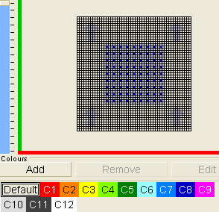 | 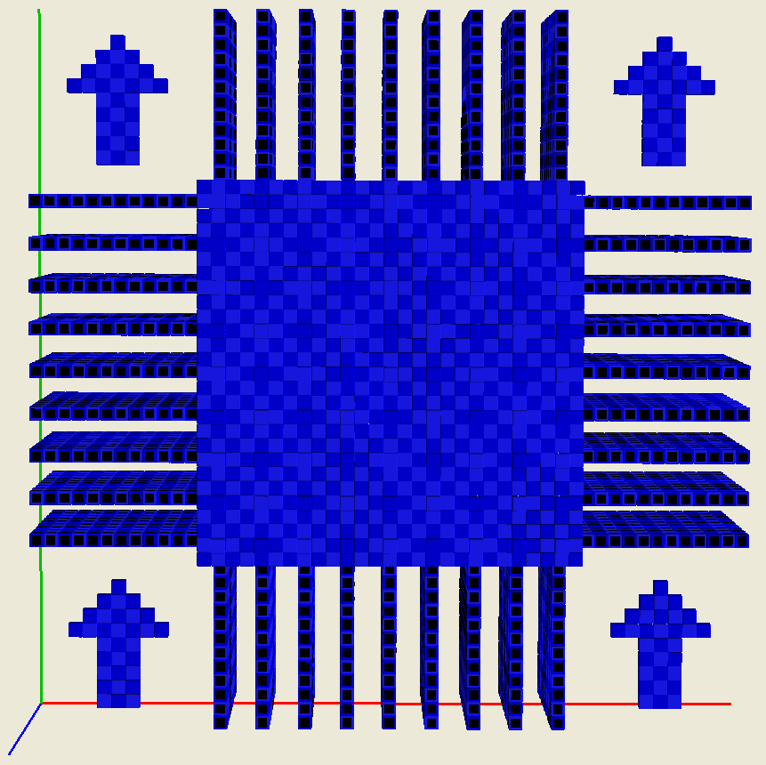
Figure 1. Top layer and corresponding front view of the SUDOKU Machine
What we have here at the front is in fact our paper grid in a big white square and 9 by 9 or 81 separate voxels in an example constraint colour on top of it. These voxels stand for the numbers we have to fill in and each number will be represented by a constraint colour as shown at the bottom of the left picture in Figure 1. Red stands for 1, orange for 2, and up to magenta which stands for 9. Or more generally: Cn stands for constraint colour n. The big arrows are there to indicate the top of our grid, making it easier to transfer our BurrTools solution to the Sudoku grid in the magazine or newspaper.
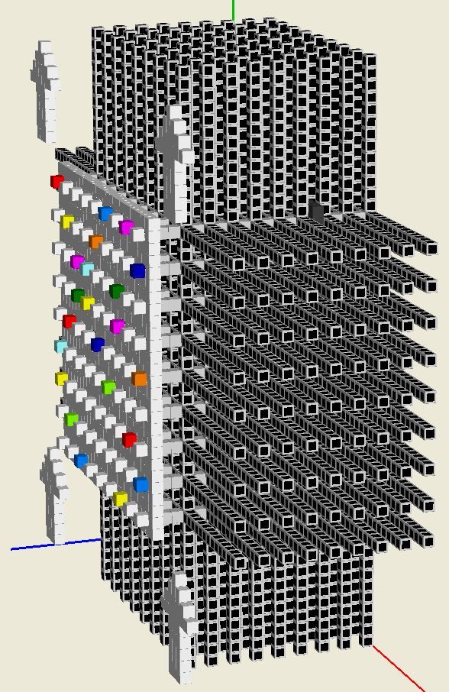Figure 2. The SUDOKU Machine
shown at an angle and with constraint colours added to the front.
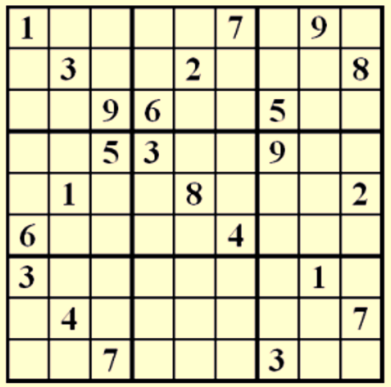Figure 3. The example
SUDOKO problem

In order to provide BurrTools with the numbers present in a Sudoku problem you just navigate to the top layer in the grid editor (that is where our 81 special voxels are to be found) and apply the appropriate constraint colour for each of the known cells. Figure 2 actually implements the example problem given in Figure 3. Note that any layer in the text to follow will correspond to its relative position in the grid editor (bottom is layer 1, top is layer 21) and not to its 3D visualization as shown in Figures 2 and 3.
Having to solve this 9 queens puzzle for the 9 different numbers is like adding an extra dimension to the queens problem. And that is exactly what we do in our BurrTools setup. We add stems so that the arms of our "numbered queens" end up in different layers as shown in Figure 4. That makes the pieces somewhat look like keys and we will further refer to them as such. The #1 keys will compete for their position on the bottom layer, whereas the #2 keys will determine their positions two layers up, and so on.

This is of course only half the story since our modification thus far does not do anything for the sub-grid restriction: A number may still occur more than once in any particular 3×3 sub-grid and be missing in another. To fulfil these sub-grid requirements we start by making 9 copies of each of the 9 keys we have thus far. Following that, we now add platforms or 3x3 squares in another of the 9 layers (double it to obtain the number of the grid layer). So all keys with the same number, as in “key 1-x”, receive different platforms thereby making them all distinct, for example “key 1-1” versus “key 1-8” as illustrated by the pictures on the left of Figures 4 and 5. These square platforms are located in the even layers of the grid.
Now it is time to have another look at the Sudoku machine in Figures 1 and 2. The latter already has the known values filled in from the Sudoku problem provided in Figure 3, and is ready for the solver to deal with it. The variable parts probably need no further explanation, but on a closer inspection of the BurrTools file you should be able to find the dark platforms (grouped in chunks the size of a sub-grid) spiralling up in between the layers. One of these darker voxels is still visible towards the top right of Figure 2 and some platforms can be seen on the left of Figure 7. These plaforms ensure that in each sub-grid a key for each number finds its place.
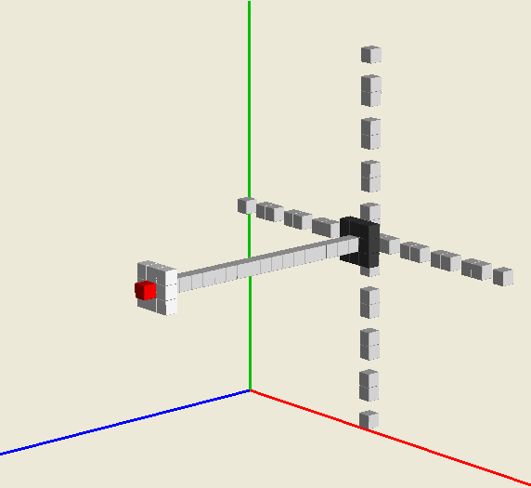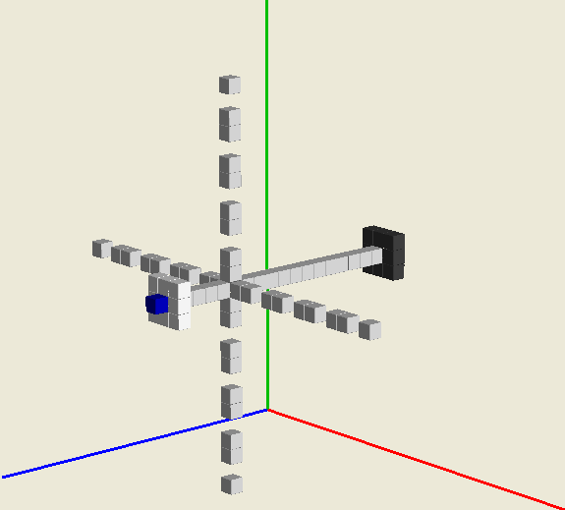Figure 4. The piece on the left is named “S3 - key 1-1” and the one on the right “S66 – key 8-1”. They are rotated such that the top grid layer, which contains a single voxel with a constraint colour, is oriented towards the left. Note that their arms are in the odd grid layers (2*1-1)=1 and (2*8-1)=15 respectively.
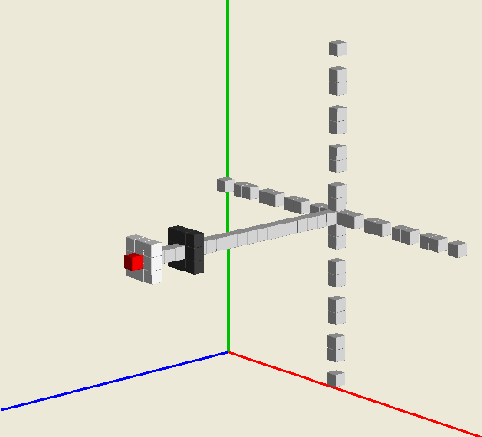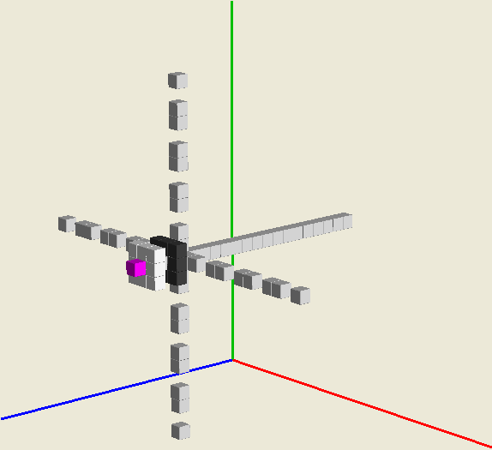Figure 5. On the left the piece called “S10 – key 1-8” and on the right “S83 – key 9-9”. Compared to Figure 4, the square platform moved from the even grid layer 2*1=2 to 2*8=16 respectively. Use of “key 9-9” should now be obvious.

Empty cells are coloured white so that the filled ones are more distinct. It is very hard to find nine constraint colours that you can easily tell apart and that above all are not too similar to the default colour. This explains the rather elaborate constraint colour settings. If the problems were defined in the original Sudoku machine, that is the one with its special voxels in the default colour, then BurrTools would suggest the correct settings when the problem definition is created.

After running the solver, you should end up with a very colorful selection of the pieces as illustrated in Figure 6. Figure 7 shows the corresponding selection of constraint colours and positioned in such a way that the rules of Sudoku are adhered to.
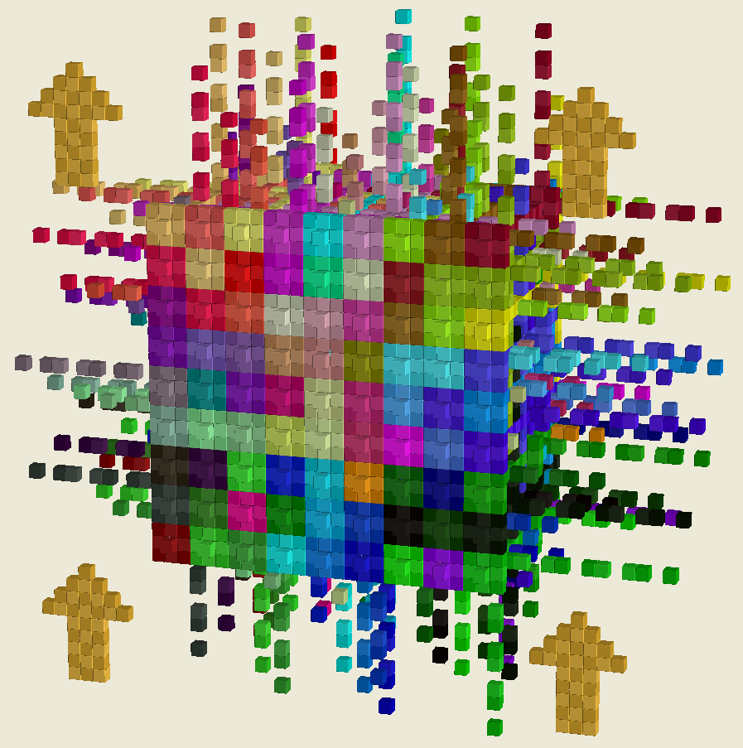Figure 6. Solution with its pieces coloured per shape
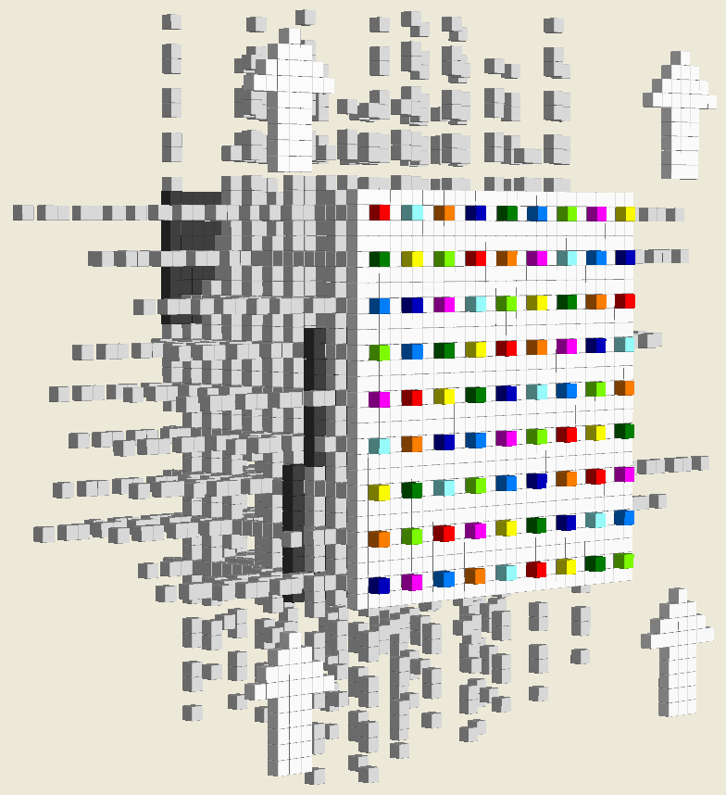Figure 7. Constraint view of solution

You may wonder why solving this problem is so much faster than the 8 queens problem from the previous installment even though this problem is at least 9 times as complex. Well, our "special voxels" and the long arms of the keys already restrict the possible positions and the platforms add even more restrictions, which means that in the end there are only 9 positions per key to be considered by the solver.

Once more, the BurrTools file is made available at the website [5]. With all the tools and techniques presented so far plus a little more additional thinking you should be able to use Burrtools to solve various matching puzzles. However the requested matching can still be different from what was required sofar. The next installment will thus introduce another kind of matching puzzle which is also quite notorious because it has only four pieces.

References
[1] Ronald Kint-Bruynseels & Rob Hegge, PuzzleWare - BurrTools (1), CFF 93 (2014), pp 20-23
[2] Andreas Röver, BurrTools, http://burrtools.sourceforge.net/
[3] Ronald Kint-Bruynseels & Rob Hegge, PuzzleWare - BurrTools (2), CFF 94 (2014), pp 24-27
[4] Simon Nightingale, Slidoku, http://www.puzzleworld.org/DesignCompetition/2014/
[5] Rik van Grol, Downloads from CFF, http://cff.helm.lu/downloads.html

